**WEEK 13 ASSIGNMENT BDWUP**

**CREATE A BLANK REPORT IN PENTAHO REPORT DESIGNER**

**Aim:**

Pentaho Report Designer - Opening Blank Report

**Algorithm:**

1.Start the process.

2.Create a Sales database using Excel.

3.Save the file in CSV format.

4.Open Pentaho Launcher tool for report generation.

5.Create a blank report.

7.Save the file.

8.Stop the process.

**OUTPUT:**

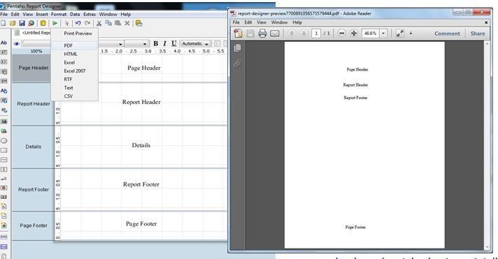

**Result :**

The above termination is executed successfully.